The Nailsworth Society ~ Membership Information

Anyone wishing to join the Society should complete the form below and send it to the Membership
Secretary together with the subscription payment (cheques made payable to The Nailsworth Society) and a stamped, addressed envelope (minimum size 6 ins x 4 1/4 ins) for return of receipt and Year Book.

Membership Secretary: Mrs J Haines,
3 Watledge Bank,
Nailsworth,
Gloucestershire,
GL6 OAY

Tel: 01453 833547
Email: family.haines@btinternet.com

I/we wish to join the Nailsworth Society
(Please print in capitals & attach cheque for £10.00 each, plus a self-addressed envelope)

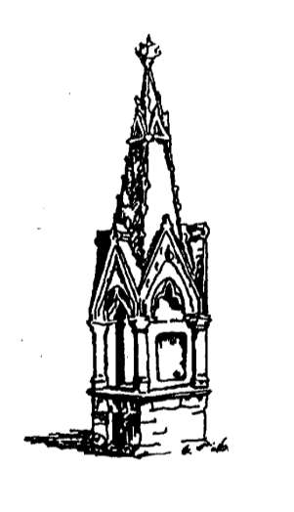

Name(s) ………………………………………………………………………………………

………………………………………………………………………………………

………………………………………………………………………………………

Address ………………………………………………………………………………………

………………………………………………………………………………………

………………………………………………………………………………………

………………………………………………………………………………………

………………………………………………………………………………………

……………………………………………………………………………………… Phone ……………………………………………………………………………………… E-mail ………………………………………………………………………………………

Please indicate Groups of interest: ACMG GG LHRG LSG RG TG/PA WG/TT

